**Assignment 20.2**

***2. Perform incremental load in Hive Read from MySQL Table and load it in Hive table. Create hive table if it does not exist. If it exists, perform the incremental load***

**Incremental append is not supported in hive as shown below and also confirmed by support team, so we will be doing in HDFS only**

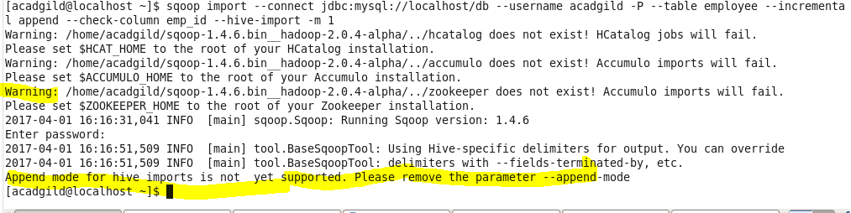

**Loading Data in HDFS from Sqoop**

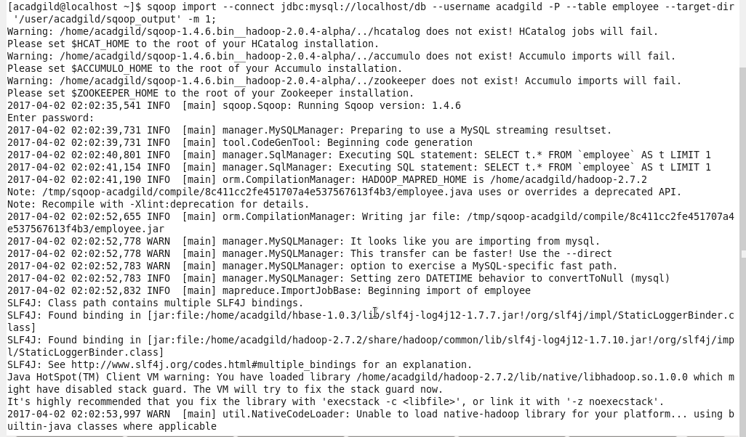

**Data loaded in HDFS**

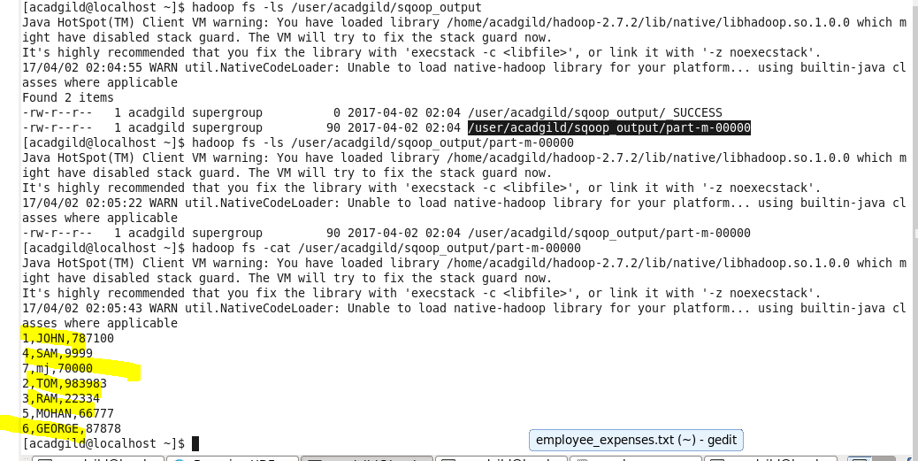

**Insert a record in Employee table in mysql**

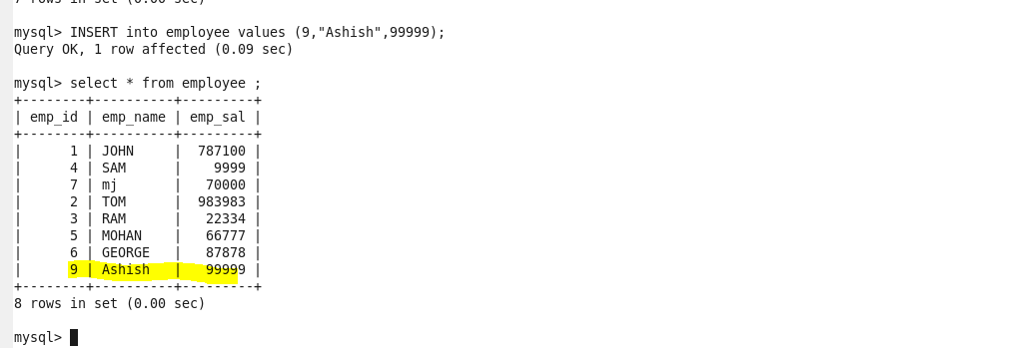

**Performing incremental load in HDFS**

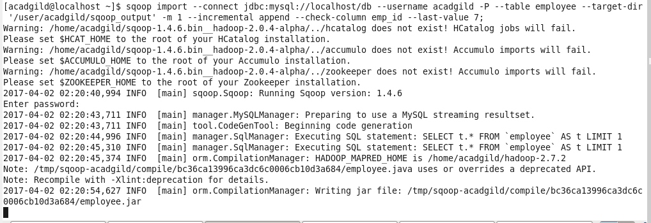

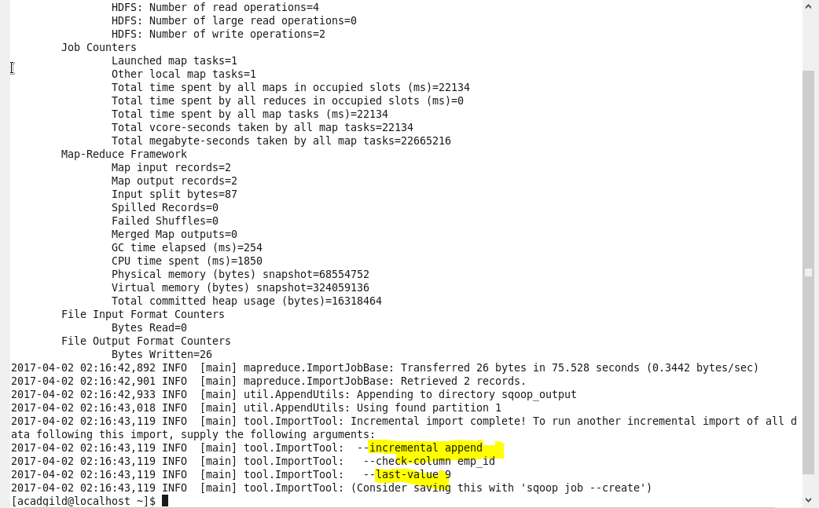

**Checking data after load in HDFS**

